week-2: (part-1C)
Assignment-01: understanding git
GIT

* GIT is the most popular version control system in the world .
developed by Linus Torvalds in 2005
a version control system recodes the change made to our code over time in a special database called repository we can look at our project history and take a look who have changed what and recover if anything goes wrong with out a version controll system we will have to go constantly stored copies of the entire project in various folders this is very slow and dosent scale at all ,especially if multiple people have to work on the same project you will have to constantly toss around the latest code via email or some other mechanisms and the manually merge the changes . In a nutsull with a version control system we can track our project history and work together .version controll system can fall into two categories
1.centralized
2.distributed

* In a centralized system all team members connnecte to a central server to get the latest copy of the code and to share their change with others subversion and microsoft team foundation server are examples for centralized version control system the the problem with the centralized architecture is the single point of failure if the server goes offline we cannot collaborate or save snapshots of out project so we have to wait untill the server comes back online in distributed system we dont have these problem every team member has a copy of their project with its history on their mechine so we can save snapshots of our projects locally on our machine if the central server is offline we can synchronize our directly with others .
*GIT and mercurial are example of distributed version control system out of all these git is the most popular version control system in the world because its free , open source , super fast and scalable .operations like branching and merging are slow and painful in other version control system like subversion of tfs but they are very fast in git so git is almost everywhere more than 90% of the softwear project in the world use git thats why almost every job description for software developer mentions git .

* A system for keeping track of changes that across a set of files . let us consider an opened directry on your local system with an editor like vs code then run git in it from the command line we just created a git repository or a repo in living in the hidden git directory and keeps tracking of all the changes that happen to these files as you work on a code base you take snapshots or commits of the current state of this file every commit has a unique idea and it is linked to its parent {commit:a snapshot of your files(code)} and this means we can travel back to our files to know the previous version of our files .
we might notes our source controll icon is messy or have somany files which are not updated ,currentrly our files are untracked we need to add tgem to repo then we use “git add” to include or stage this files in the repo then creat a snapshot of their current state by running git commit along with the message that what we actually did to this files “git commit-yes ‘got it’ ” we jus created a firs commit on the head the ,head is called as most recent commit.the changed files will be disappeard and now we will be on a clean working directory . if we make some changes and commit them to repo the head moves forward but we will still have a referance to our previous commits so we can always go back to it.
branch : an alternate history for your code
merge : combine branches into a single codebase.

key features:

* Distributed:Every developer’s copy of the code is a repository with full history.
* Branching and merging : allows for parallel development and merging of changes.
* Performance : Optimized for speed in committing ,branching,merging,and comparing changes.
* Content Focus: Tracking changes based on content rather then file name , enhancing flixibility.
*Security:provides mechanisms for authentication and authorization.

Benifits:
* it enables collaborative development.
* git also facilitates tracking of changes and versions.
* improves th work flow efficiency
* enhances code management and organization.
uses
* manages software projects of any size
* collaborating with remote teams
* tracking changes and rolling back to previous versions
commands:
* git init : this command initializes a new git repository
* git add : this command adds changes to staging area
* git commit : this command saves the changes to repository
* git push : this command sends local changes to a remote repositary
* git pull : this command fetches changes from a remote respository and merges them into the local branch .

GITHUB
web based hosting service for git repositories ,offering a platform for collabarative development.it provides features beyond basic version control,such as issue tracking project management ,and code review tools.it facilitates community engagement through features like pull requests,which allow developers to propose changes and collabarate with code it provides visibility into projects through features like wikis, README files, and project documentation, making it easier for developers to understand and contribute to projects.

Assignment-02:Create a git repositry
How to creat a git repository with README file

To create a git repository with readme file we need to sign in to github website https://github.com
* click on + icon in the top right corner of the page and select New repository.
alternatively ,we can navigate to our profile by clicking on profile and select your repositories then click on “new” button .
*fill the repository details like the name directory on the computer
* then we choose initilize the repository with readme file ,which helpful for us to provide information about your project.
*now the final step is to click on “create repository”.
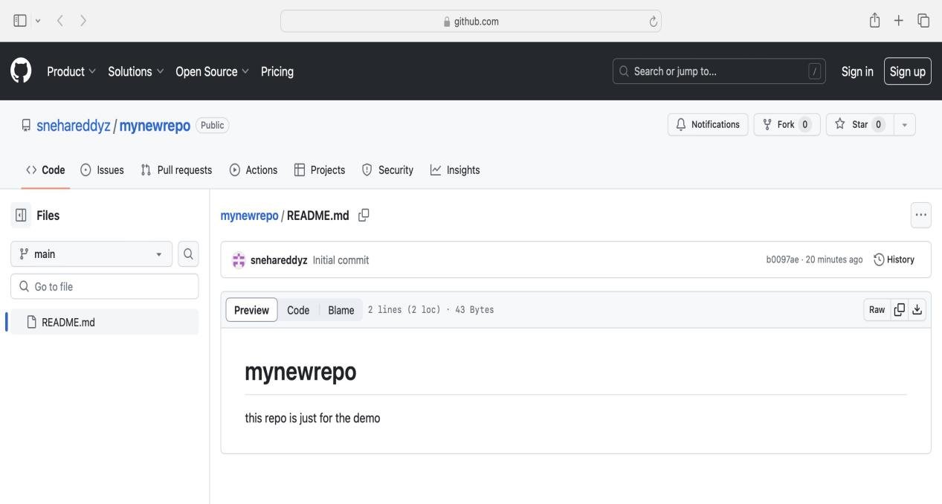
here we can see a repository in the name of “mynewrepo”
where the information is
“this repo is jus for the demo”
here is the link provided for clarity
https://github.com/snehareddyz/mynewrepo

Assignment-03: version control system with git

version control system
version control system track changes to file over time ,facilitation collaboration and managing code revising in software development projects. vcs allows multiple developers to work on same code base simultaneously,with some changes recoded incrimently .it provides mechanism for creatingbranches, enabling developers to work on isolated features or fixed without affecting the main codebase.vcs supports merging branches back into the main codebase ,preserving changes made by different developers.it even helps in identifies who made specific changes and when,aiding debugging and accountability.
VCS systems ensure data integrity and security through access control mechanisms and authentication protocols. They facilitate code reviews and audits, promoting best practices and code quality standards. VCS supports continuous integration and deployment pipelines, automating code deployment processes. They are essential tools in modern software development, enabling efficient team collaboration and project management. VCS systems are adaptable to various types of projects, including web development, mobile app development, and enterprise software solutions. They provide features for tagging releases, labeling milestones, and managing project documentation. VCS systems integrate seamlessly with popular development tools and platforms, enhancing developer productivity. They are scalable, capable of handling projects of all sizes, from small startups to large enterprise applications. VCS systems offer versioning capabilities not only for source code but also for documentation, configuration files, and other project assets. They promote transparency and traceability in project development, fostering a culture of accountability and collaboration among team members.

creating a new branch in the name of “feature-branch”
* in the following screenshot we can notice the branch in the name of feature-branch
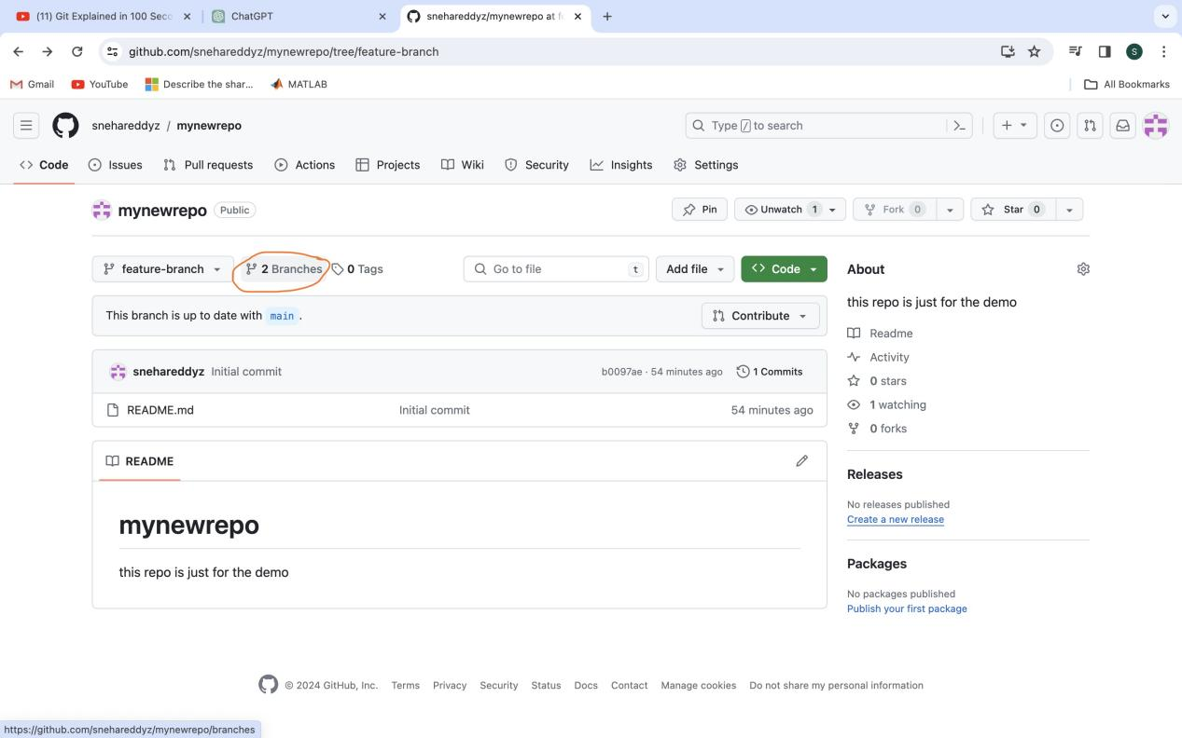

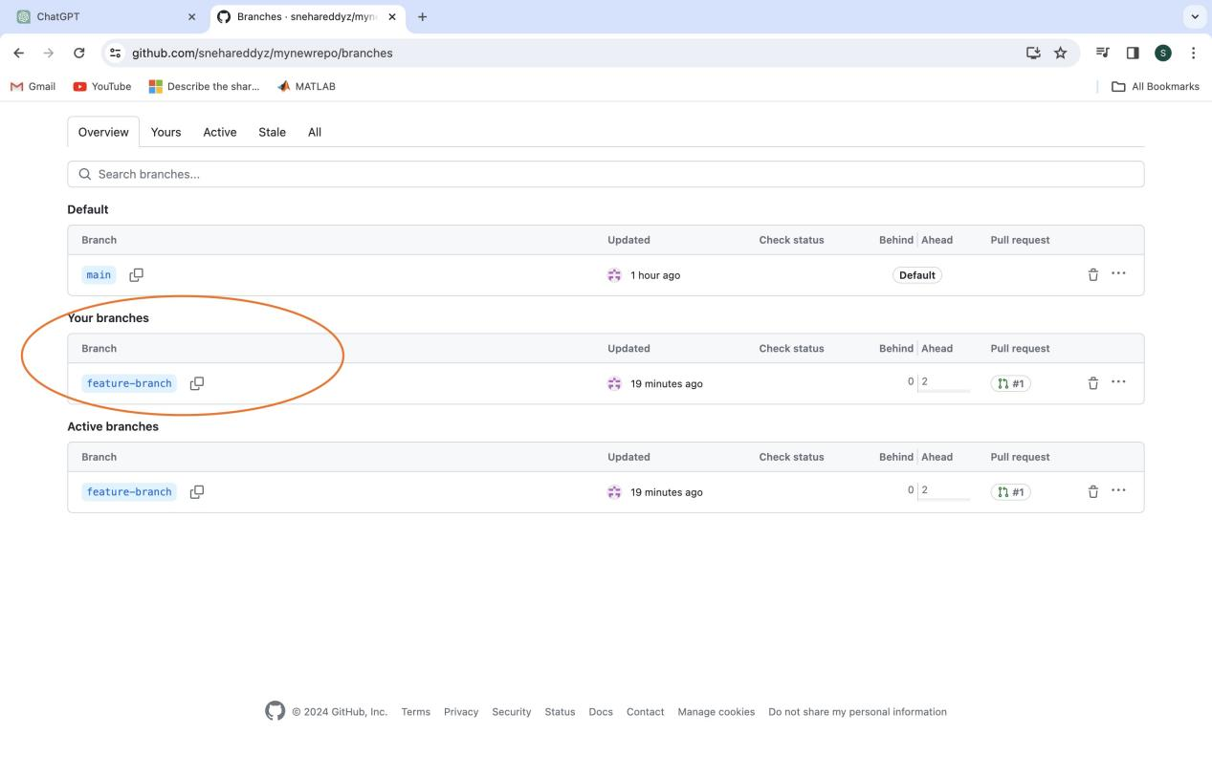
here is the link for more clarity
https://github.com/snehareddyz/mynewrepo/branches

Assignment-04 : introduction to parallel computing
parallel computing :
parallel computing refers to the simultaneous excuation of multiple tasks or processes to solve a computational problem. in treditional serial computing ( which is not parallel or the normal computing we use often insted of parallel computing ) taskes are excuated sequentially one after the other
increased performance: parallel computing allows for the efficient utilization of multiple progcessing unit , such as CPU and GPU and specialized accelerators like FPGAs, also reduce the time required to solve complex problems.
Scalibility:
This scalibility is usefull for handling the large datasets, performs simulations with high levels of detail, and addtessing computational challenges in scientific research , and data analysis.
cost-effectiveness:
parallel computing organizations to archieve higher computational throughput without nessessarily investing in faster processing

technological advancements:
advances in parallel computing architectures, programming models, and algorithams continues to drive innovation in modren computing .more over advancements in parallel programming languages libraries and frameworks simplifiy the development of
parallel applications and making parallel computing more accessible to developers .

serial computing and parallel computing
Execution model:
multiple tasks are
executed ,with multiple processing unit
Performance:significantly improved performences
scalibility: highly scalable on large number of processing units
Resource utilization:
enables efficient utilization of multiple processing units By leveraging multiple processing units concurrently, parallel computing enables faster execution of complex computations

parallel computing
Execution model:
tasks are executed sequentially,one after the other on a single processing unit
Performance:limited performances long computing time
scalibility: lacks scalability as it relies on a single processing unit.
Resource utilization:
utilizes only a single processing unit and inefficient use of computational power.
serial computing

Assignment-05 : GPU and CUDA

GPU and its role in computing
(Graphics processing unit)
specialized electric circuit designed to accelerate the rendering of images and graphics in computers, gamings etc

explain the importance of learning nvidia CUDA in the context of parallel computing and machine learning

understanding CUDU
(compute unified device architecture) is a software framework developed by NVIDIA which explains the capability of gpu acceleration it allows developers to access the raw computing power to process data faster then normal CPUS, this way its popular among IT specialists
it anables the parallel processing by breaking down a task into 1000’s of smaller “threads”

